Supplementary Material
Complete sequencing and comparative genomic analyses of Bacillus sp. S3, a novel hyper Sb(III)-oxidizing bacterium

Jiaokun Li^{1,2}, Tianyuan Gu^{1,2}, Liangzhi Li^{1,2}, Xueling Wu^{1,2}, Li Shen^{1,2}, Runlan Yu^{1,2}, Yuandong Liu^{1,2}, Guanzhou Qiu^{1,2} and Weimin Zeng^{1,2*}

* Correspondence: Weimin Zeng: zengweimin1024@126.com

Supplementary Figure legends
Supplementary Figure 1 Energy dispersive X-ray spectroscopy (EDS) analysis of Bacillus sp. S3 before and after the various heavy metal ions exposure: Sb(III) (A); As(III) (B); Cd(II) (C); Cr(VI) (D); Pb(II) (E); Cu(II) (F).
Supplementary Figure 2 COG classification statistics of the Bacillus sp. S3 genome annotation.
Supplementary Figure 3 GO classification statistics of the Bacillus sp. S3 genome annotation.
Supplementary Figure 4 KEGG classification statistics of the Bacillus sp. S3 genome annotation.
Supplementary Figure 5 Distribution of CAZymes in Bacillus sp. S3.
Supplementary Figure 6 Gene content of the intact prophage in strain S3 predicted by PHAST.
Supplementary Figure 7 Comparison of G+C contents of these functional genes with those of the average of the entire genomes. (A) arsB_1; (B) arsB_2; (C) arsB_3; (D)arsC.
Supplementary Figure 8 Neighbor-joining phylogenetic tree of concatenated AioB protein sequences derived from Bacillus sp. S3 and other representative species. Bacillus sp. S3 was marked in red blot.
Supplementary Figure 9 Maximum likelihood phylogenetic tree of concatenated AioB protein sequences derived from Bacillus sp. S3 and other representative species. Bacillus sp. S3 was marked in red blot.
Supplementary Figure 10 Phylogenetic tree analysis based on concatenated AioB protein sequences using UPGMA method under p-distance model. Bootstrap values are indicated at each node based on a total of 1,000 bootstrap replicates. Bacillus sp. S3 was marked in red blot.
Supplementary Figure 11 Neighbor-joining phylogenetic tree of concatenated ArsB protein sequences derived from Bacillus sp. S3 and other representative species. Bacillus sp. S3 was marked in red blot.
Supplementary Figure 12 Maximum likelihood phylogenetic tree of concatenated ArsB protein sequences derived from Bacillus sp. S3 and other representative species. Bacillus sp. S3 was marked in red blot.
Supplementary Figure 13 Phylogenetic tree analysis based on concatenated ArsB protein sequences using UPGMA method under p-distance model. Bootstrap values are indicated at each node based on a total of 1,000 bootstrap replicates. Bacillus sp. S3 was marked in red blot.
Supplementary Figure 14 Neighbor-joining phylogenetic tree of concatenated ArsC protein sequences derived from Bacillus sp. S3 and other representative species. Bacillus sp. S3 was marked in red blot.
Supplementary Figure 15 Maximum likelihood phylogenetic tree of concatenated ArsC protein sequences derived from Bacillus sp. S3 and other representative species. Bacillus sp. S3 was marked in red blot.
Supplementary Figure 16 Phylogenetic tree analysis based on concatenated ArsC protein sequences using UPGMA method under p-distance model. Bootstrap values are indicated at each node based on a total of 1,000 bootstrap replicates. Bacillus sp. S3 was marked in red blot.

Supplementary Tables
Supplementary Table 1 The quality control of clean date.
Supplementary Table 2 The statistical information and of clean date.
Supplementary Table 3 The statistical information of genome sequencing and assembling procedures.
Supplementary Table 4 COG functional categories of Bacillus sp. S3.
Supplementary Table 5 GO categories of Bacillus sp. S3. WEGO was used to produce the graph.
Supplementary Table 6 KEGG categories of Bacillus sp. S3.
Supplementary Table 7 Digital DNA-DNA hybridization (dDDH) between Bacillus sp. S3 and other Bacillus genomes.
Supplementary Table 8 Mobile genetic elements prediction in Bacillus genomes by different methods.
Supplementary Table 9 Primers used in Real-time RT-PCR.

Supplementary Figures

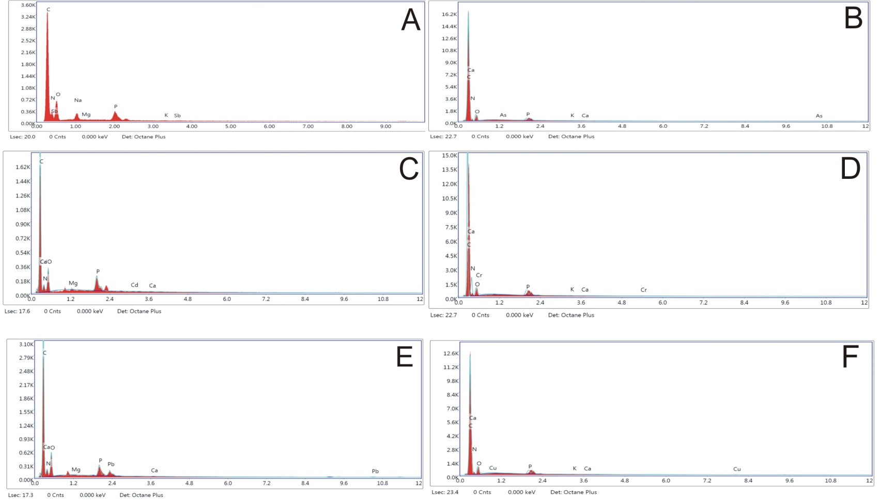
Supplementary Figure 1 .

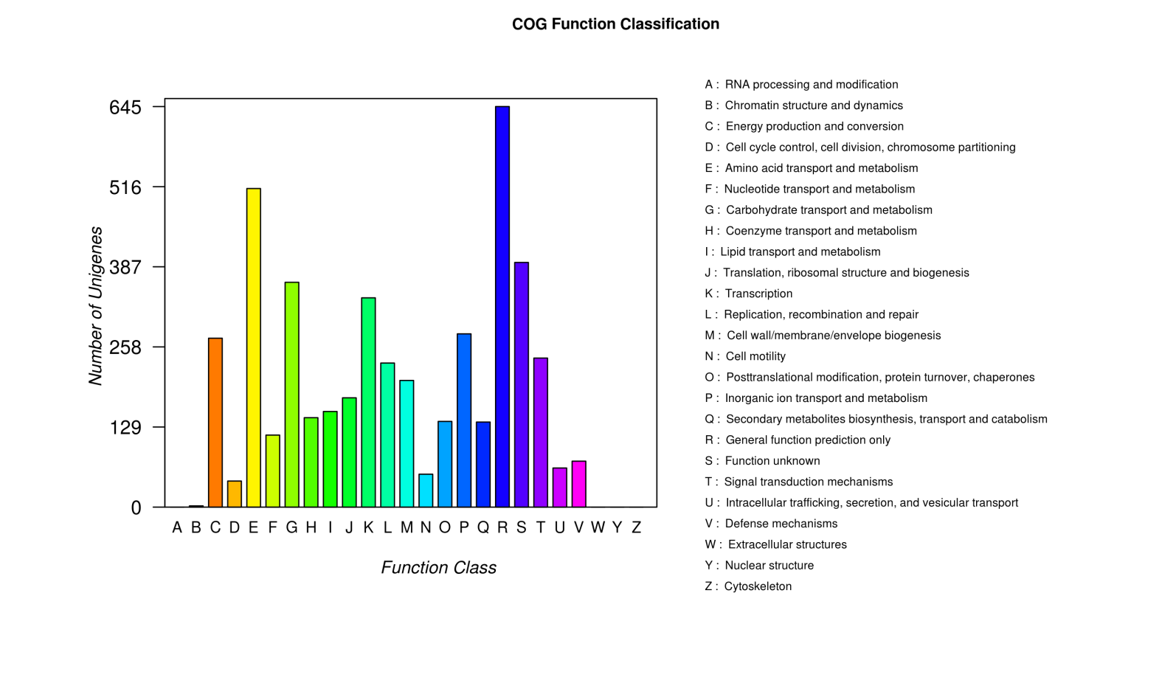
Supplementary Figure 2.

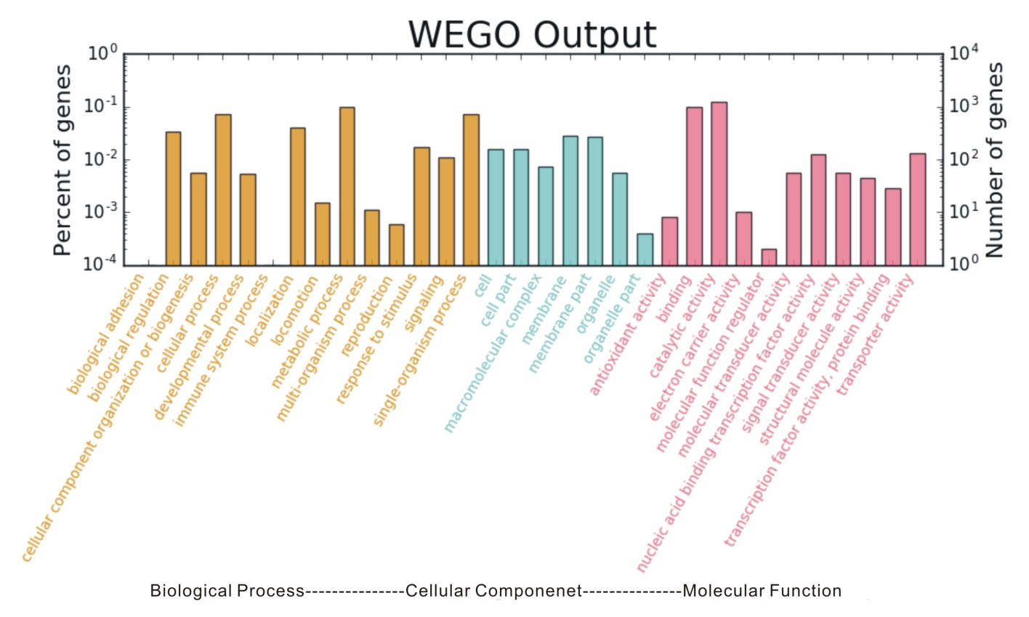
Supplementary Figure 3.

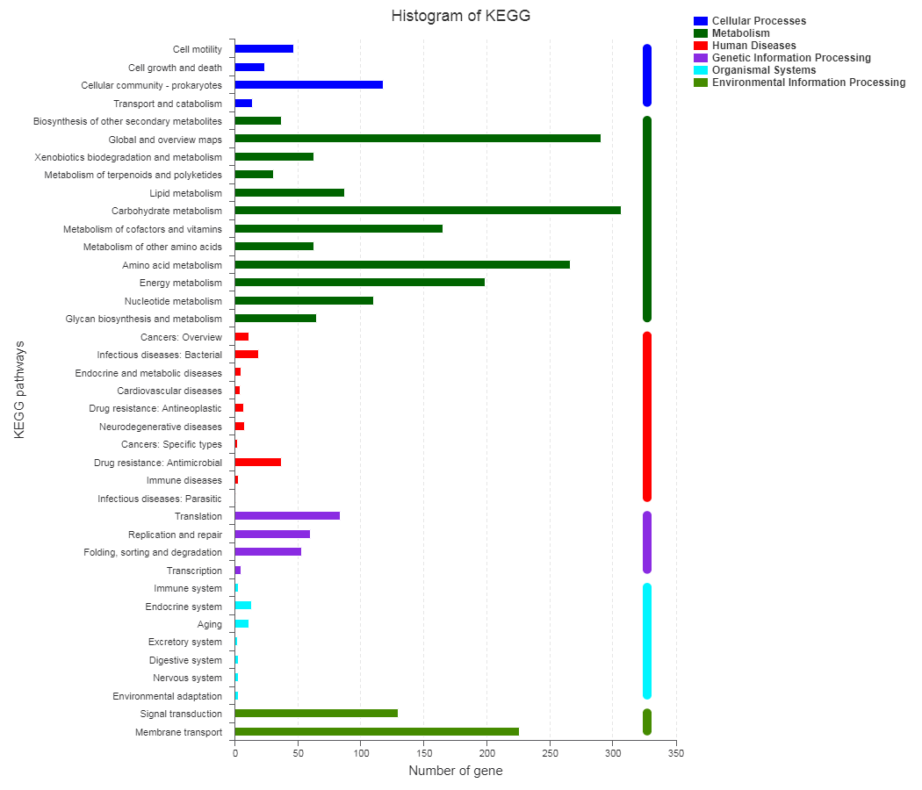
Supplementary Figure 4.
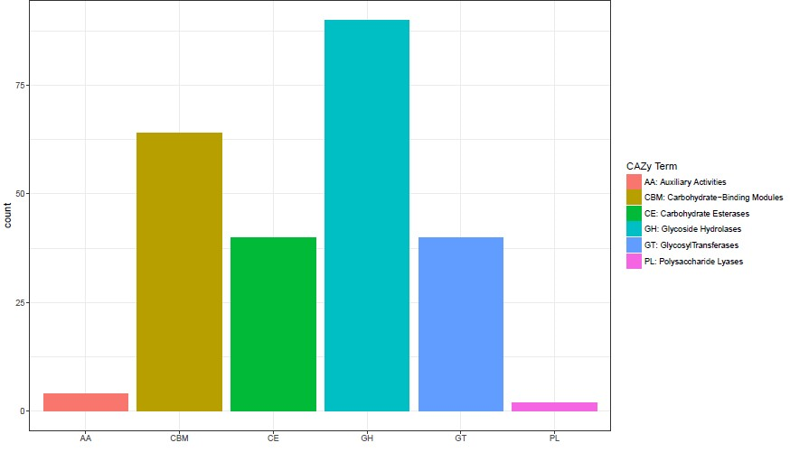
Supplementary Figure 5 .

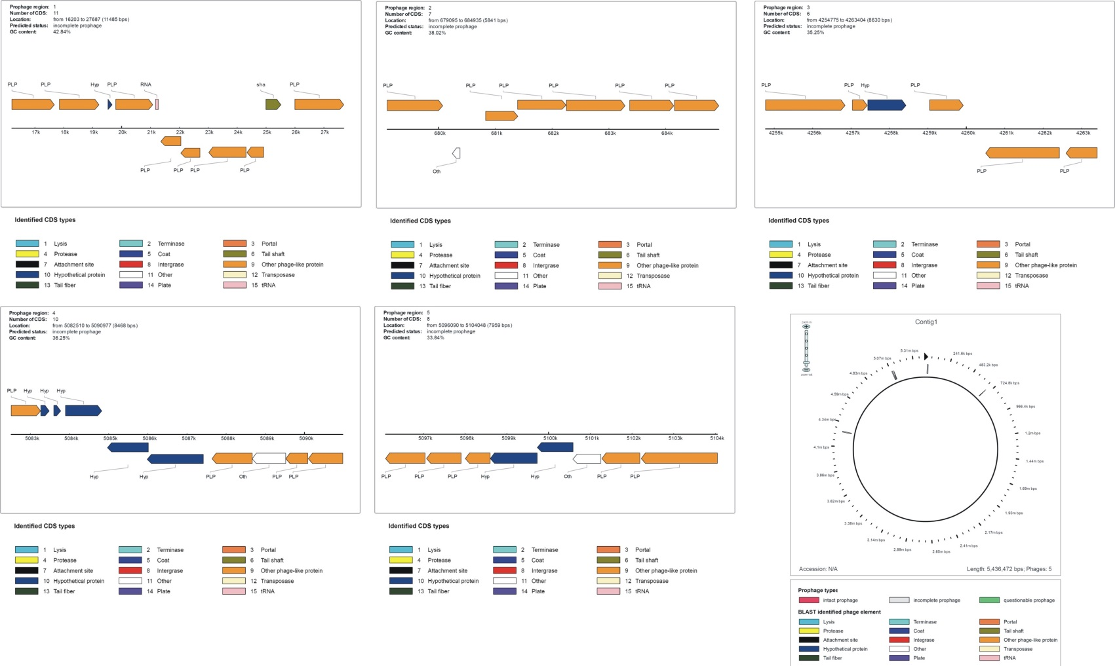

Supplementary Figure 6.
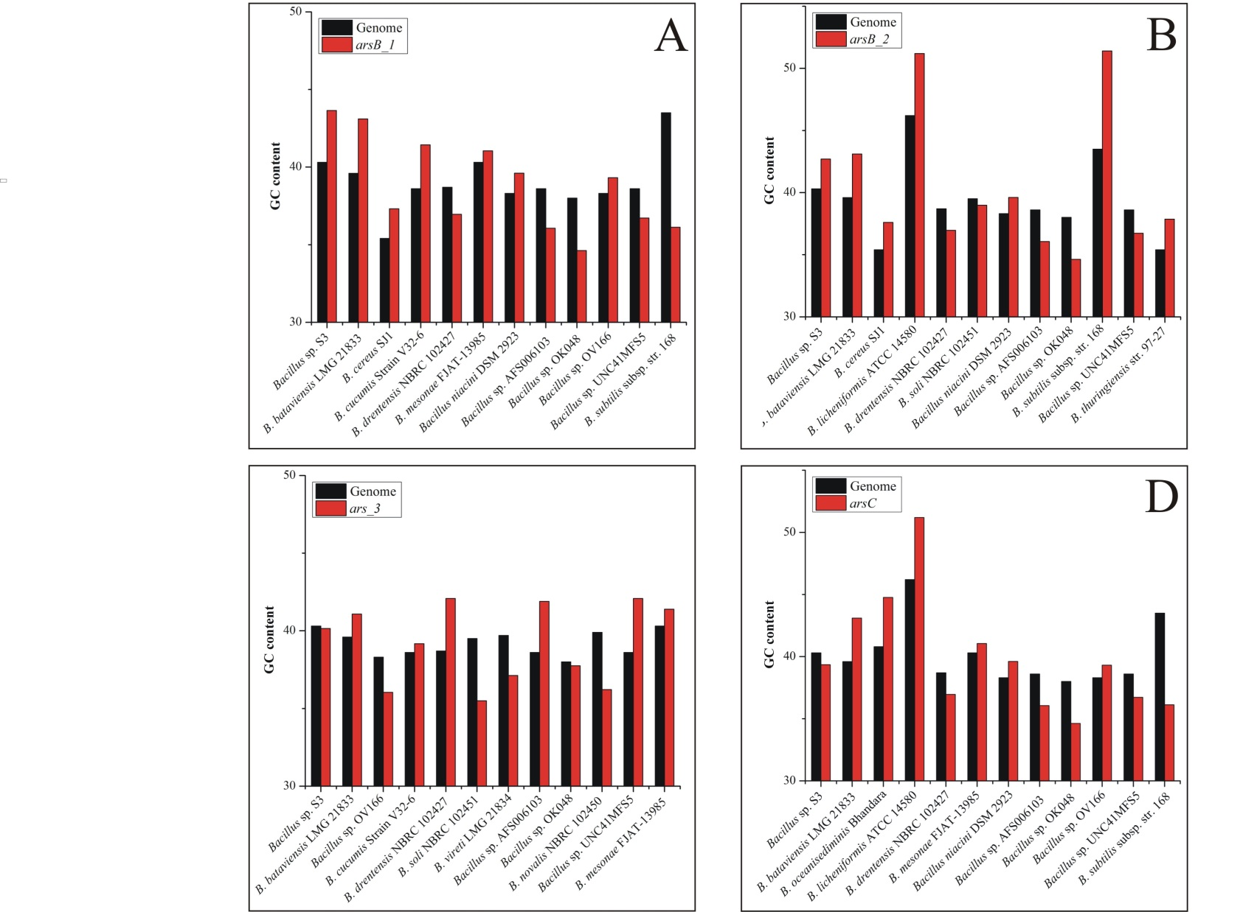
Supplementary Figure 7.
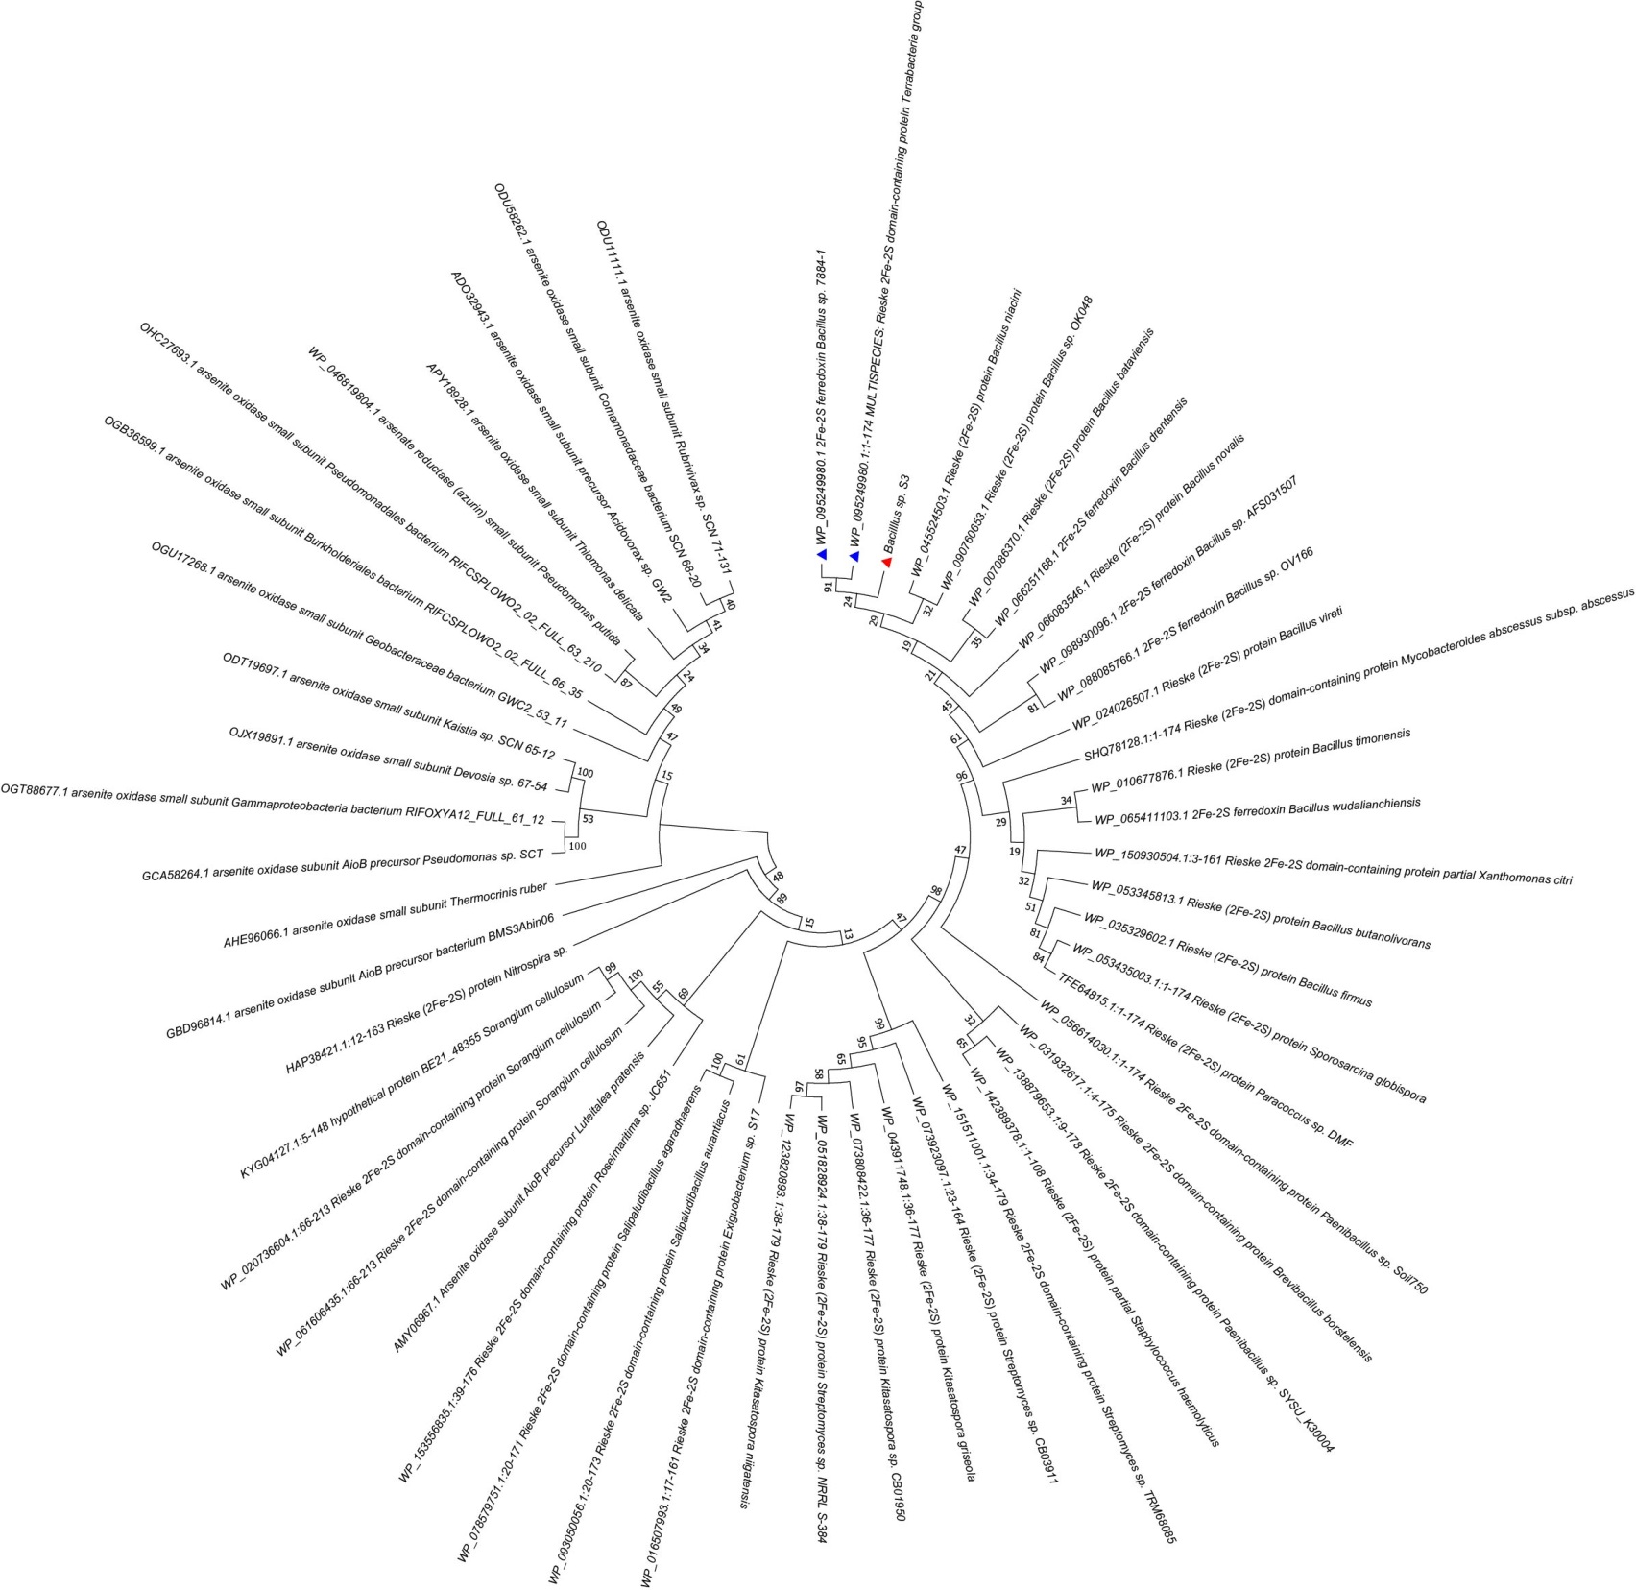
Supplementary Figure 8.
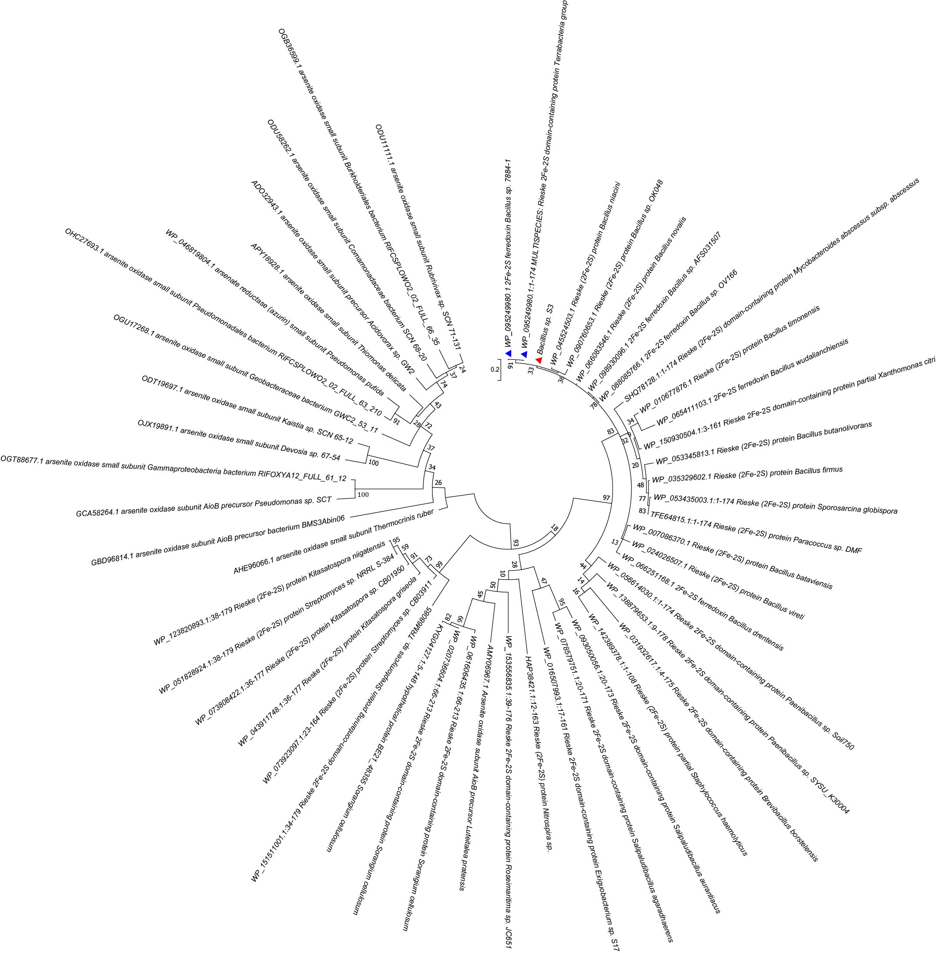
Supplementary Figure 9.
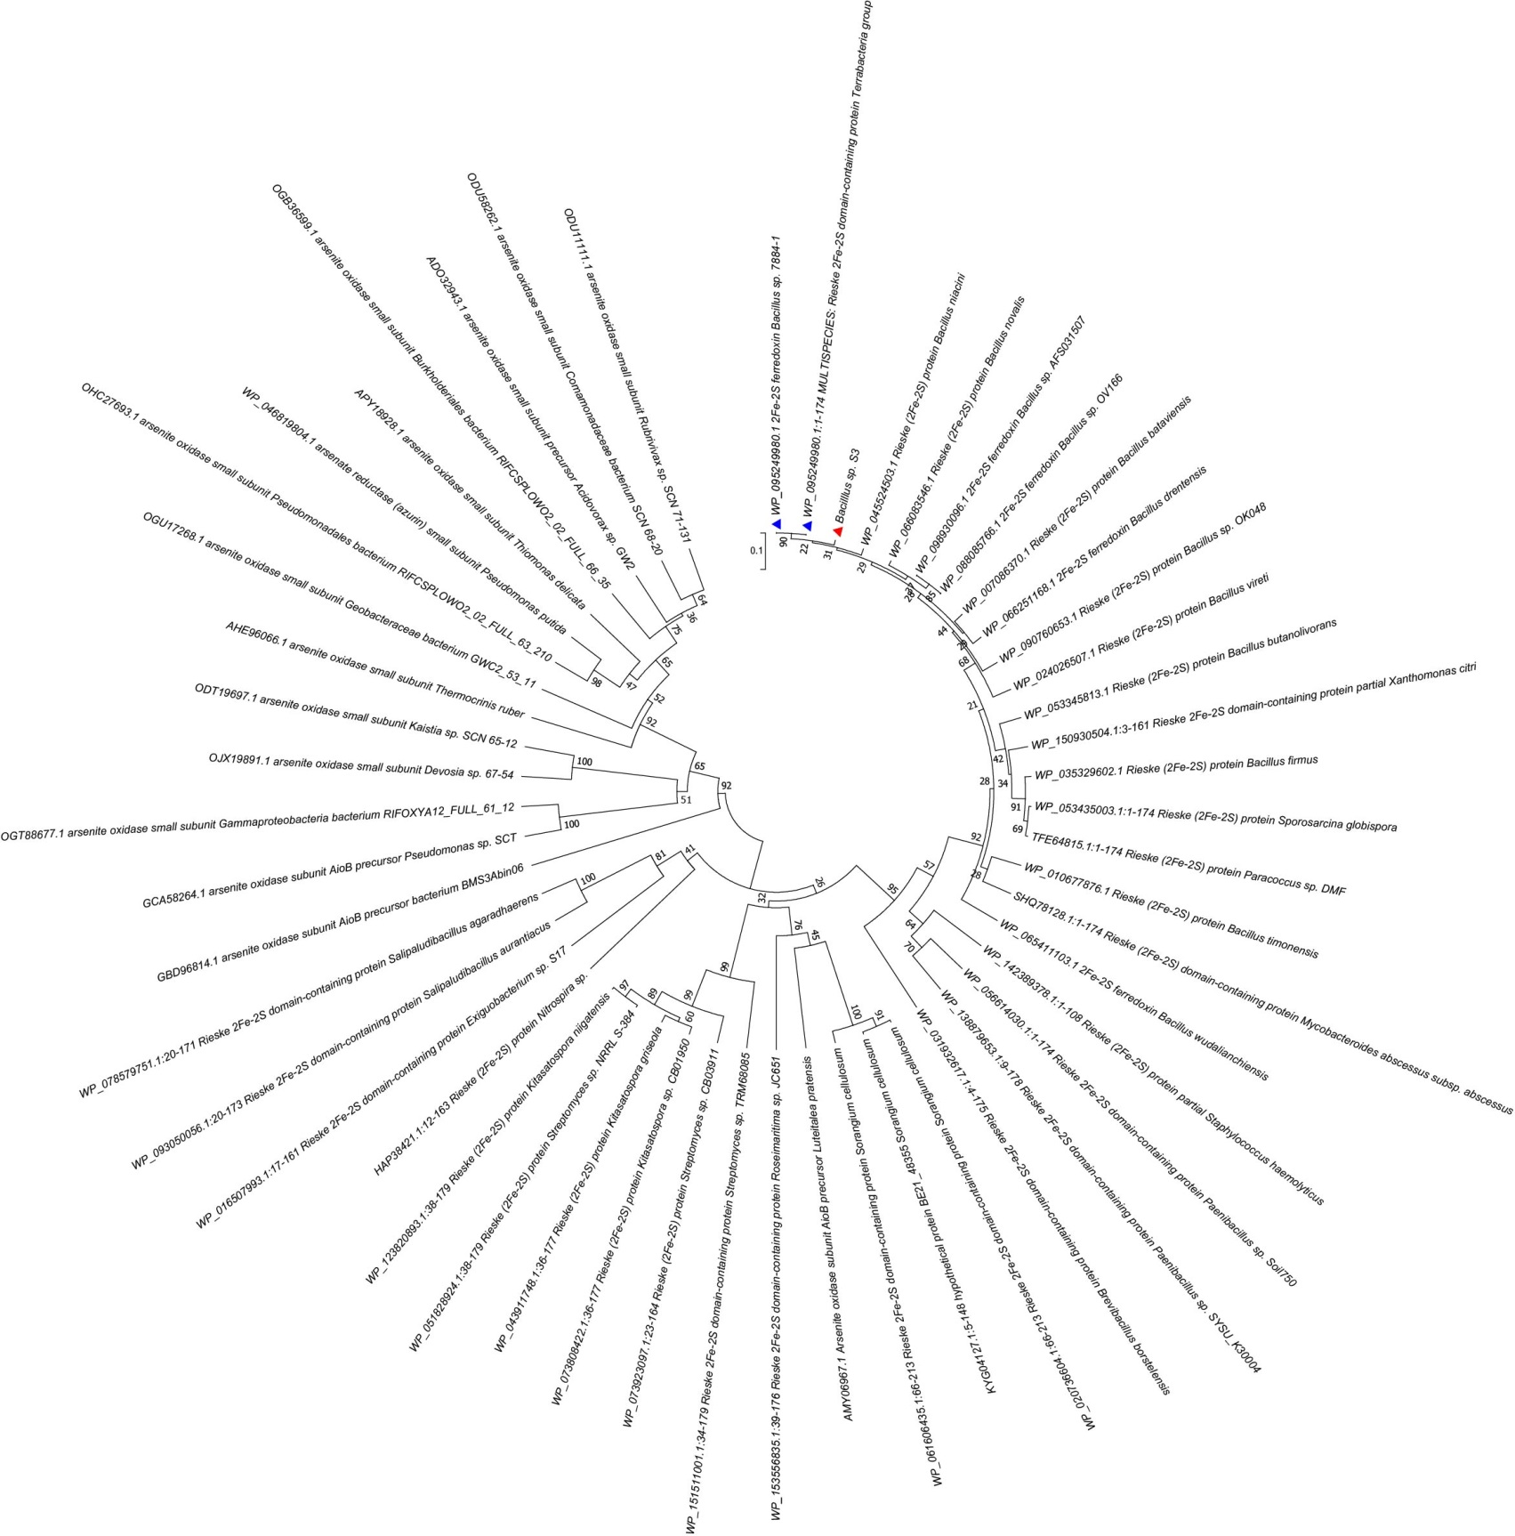
Supplementary Figure 10.
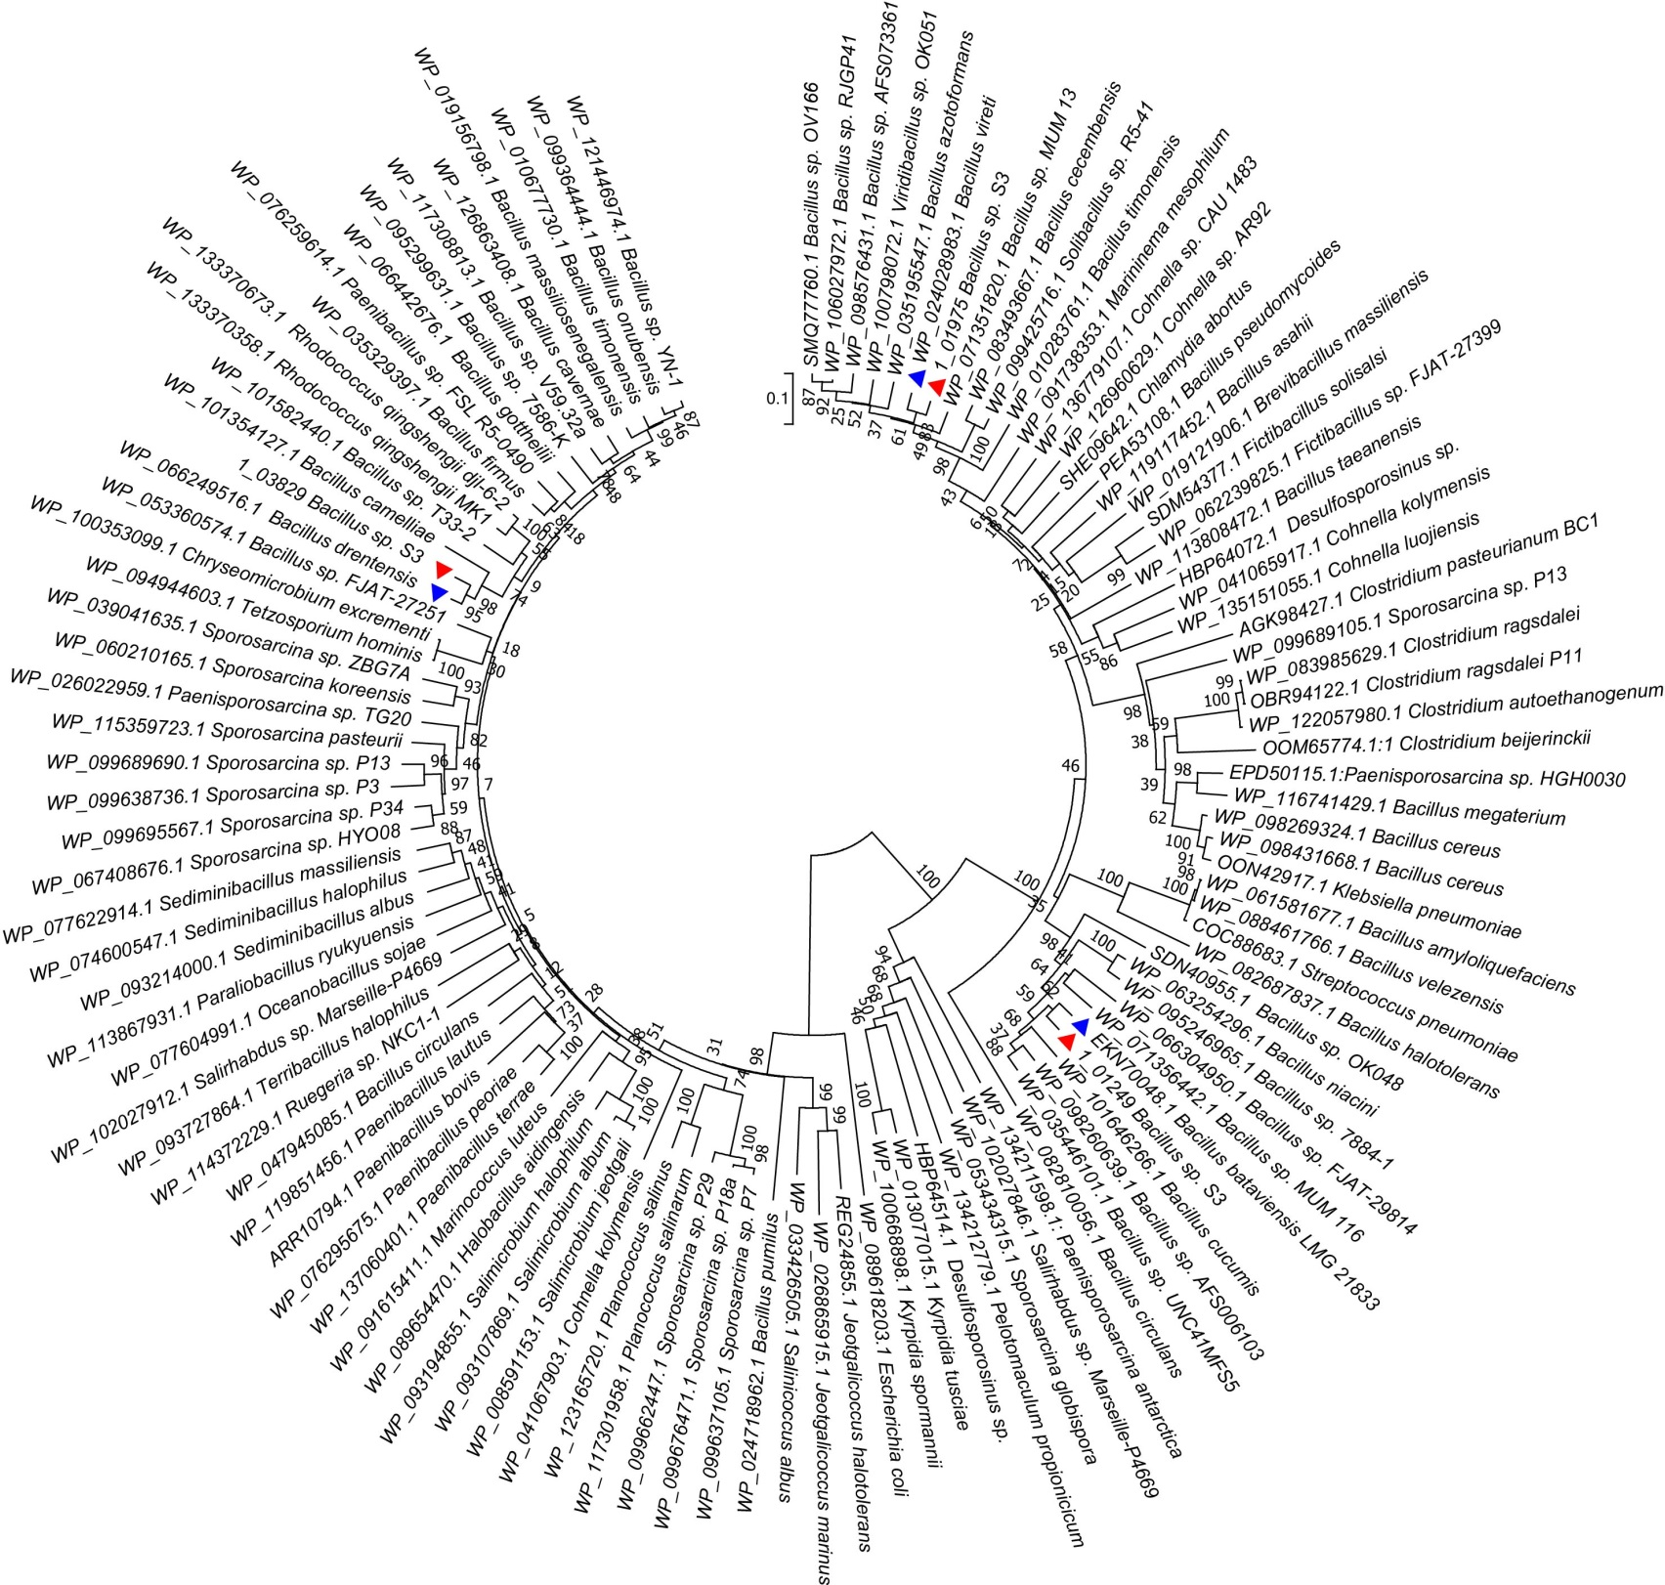
Supplementary Figure 11.
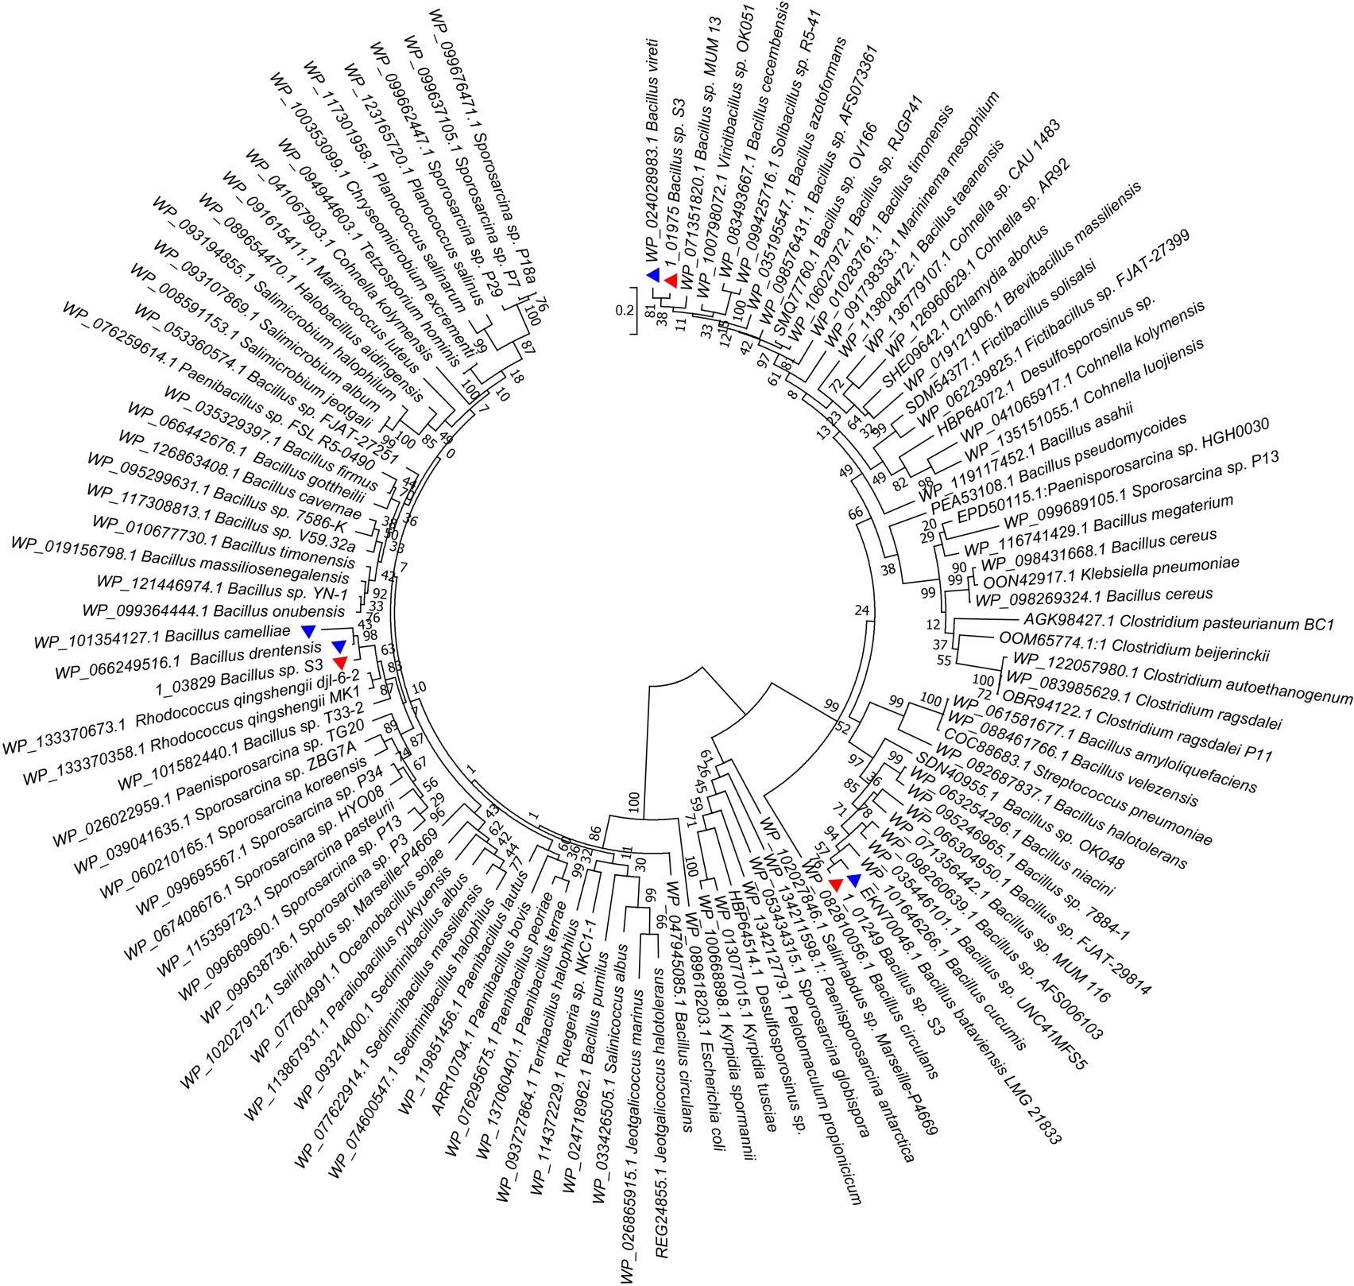
Supplementary Figure 12.
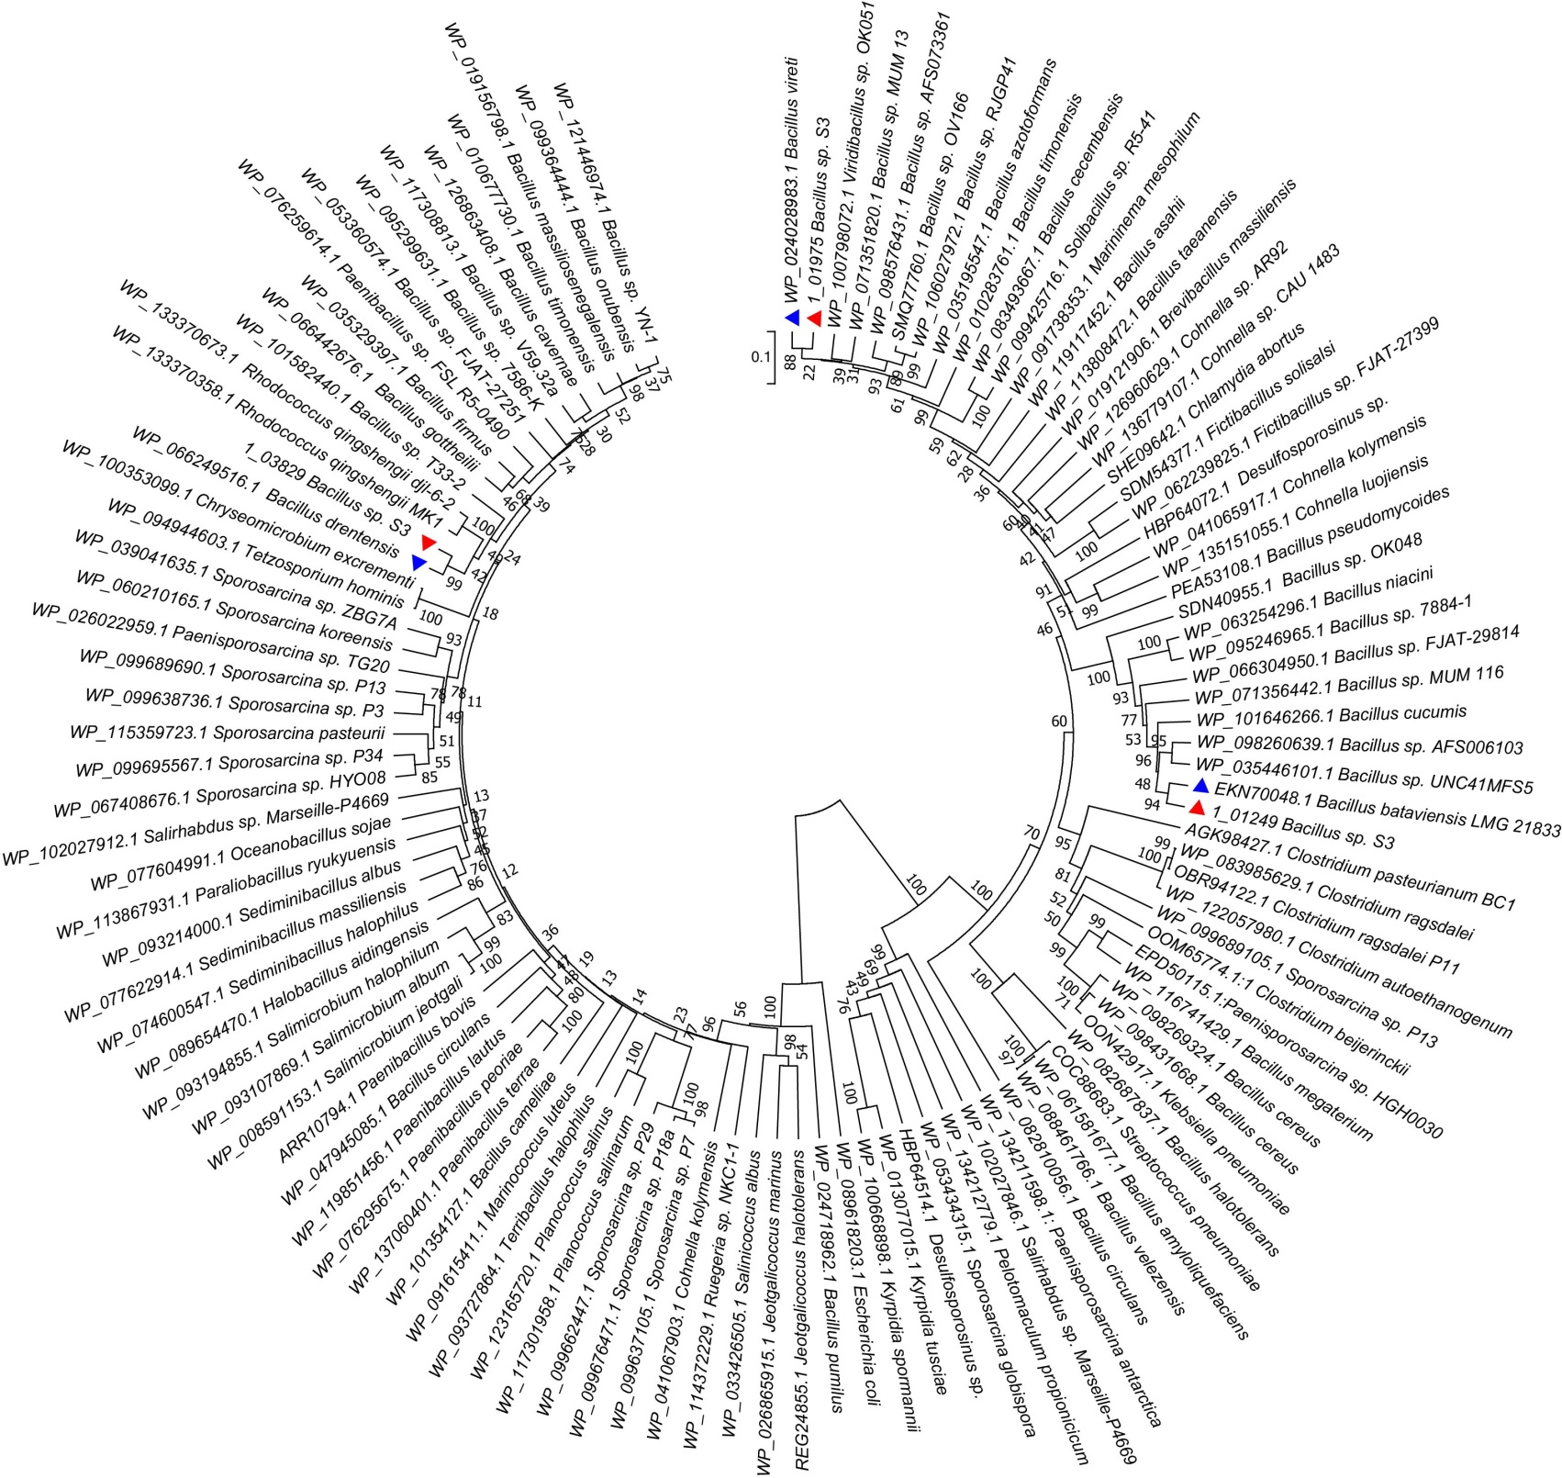
Supplementary Figure 13.
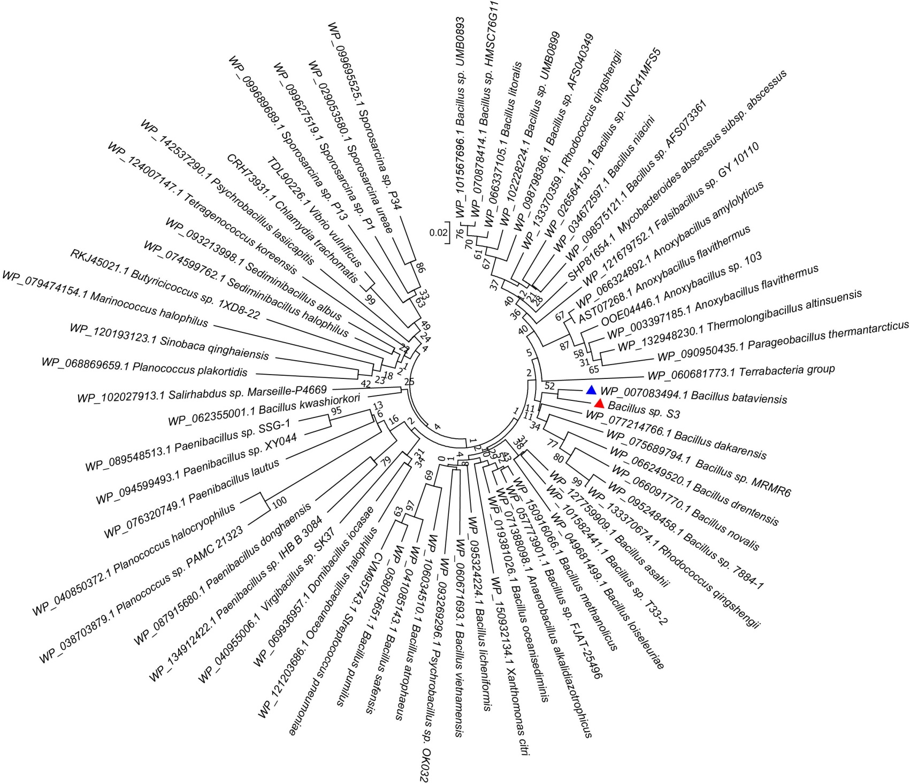
Supplementary Figure 14.
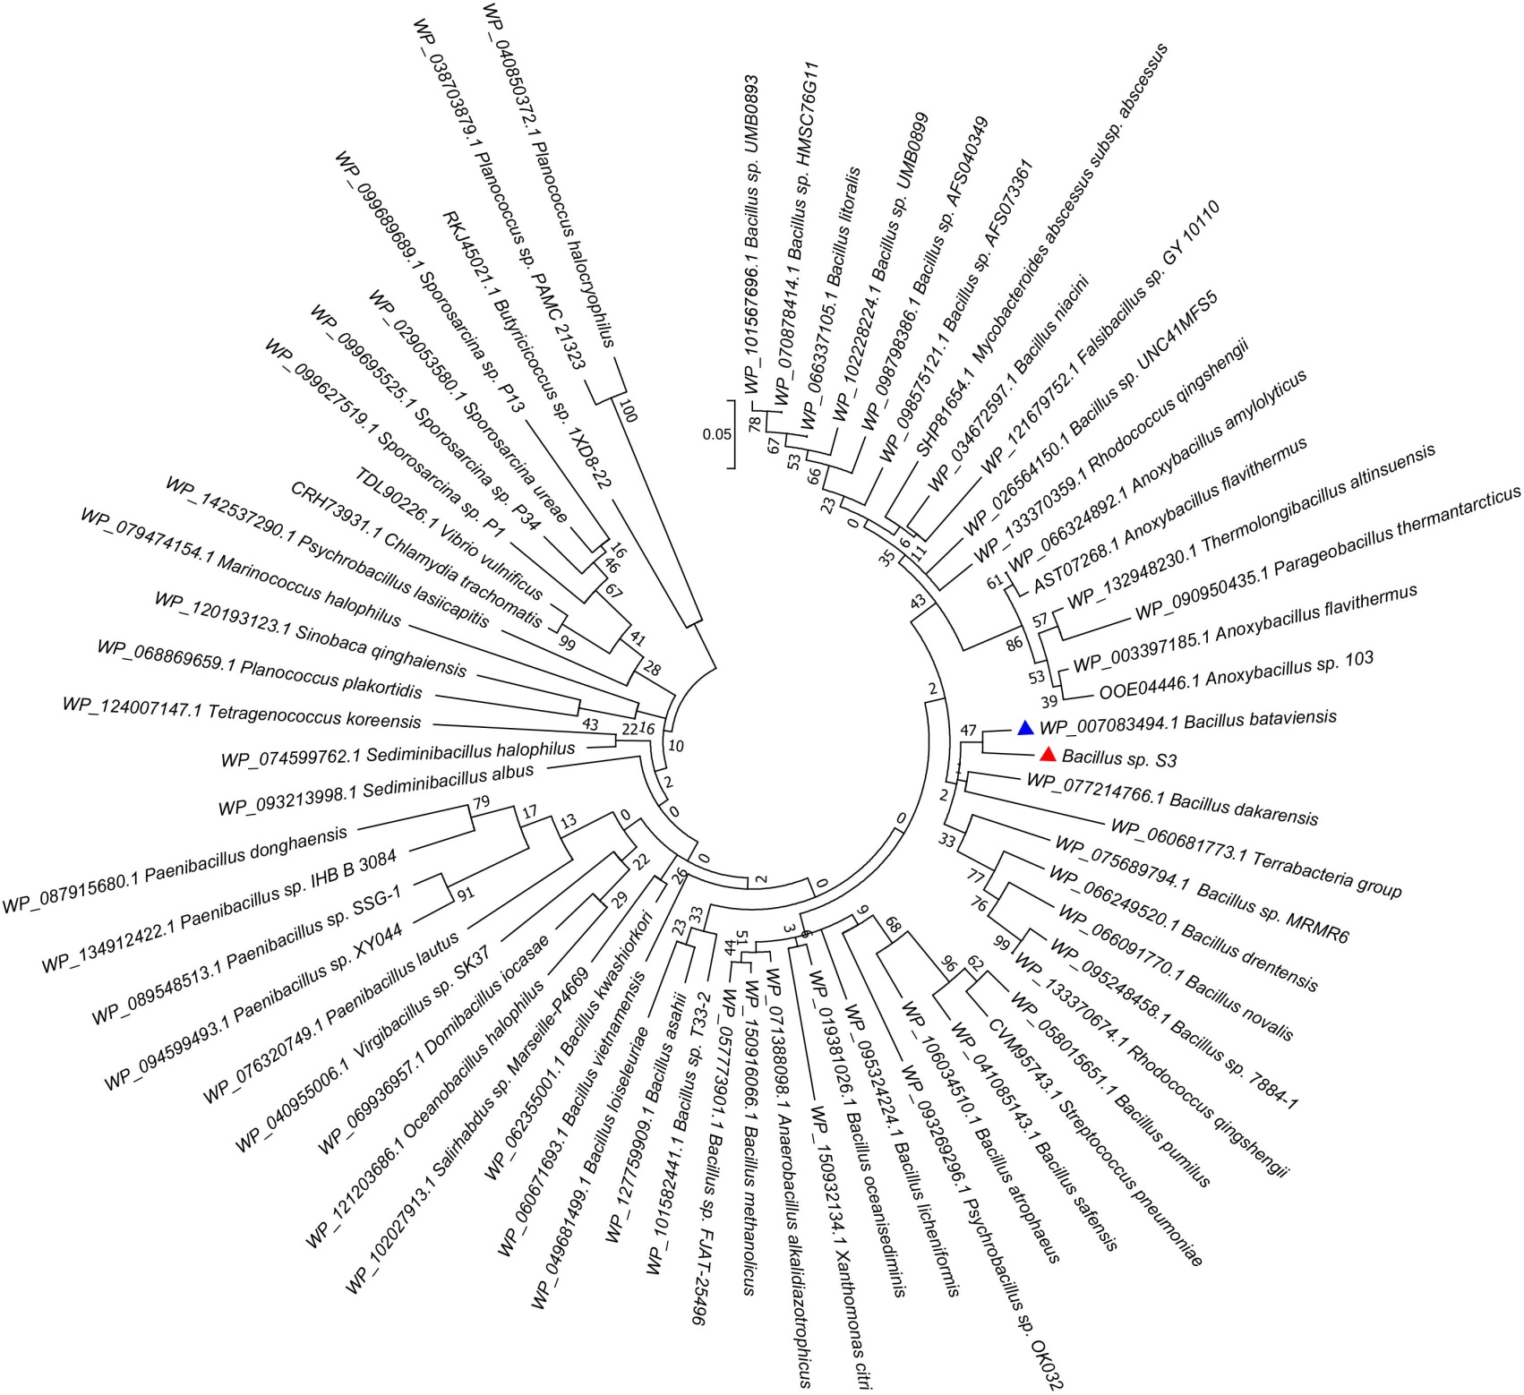
Supplementary Figure 15.
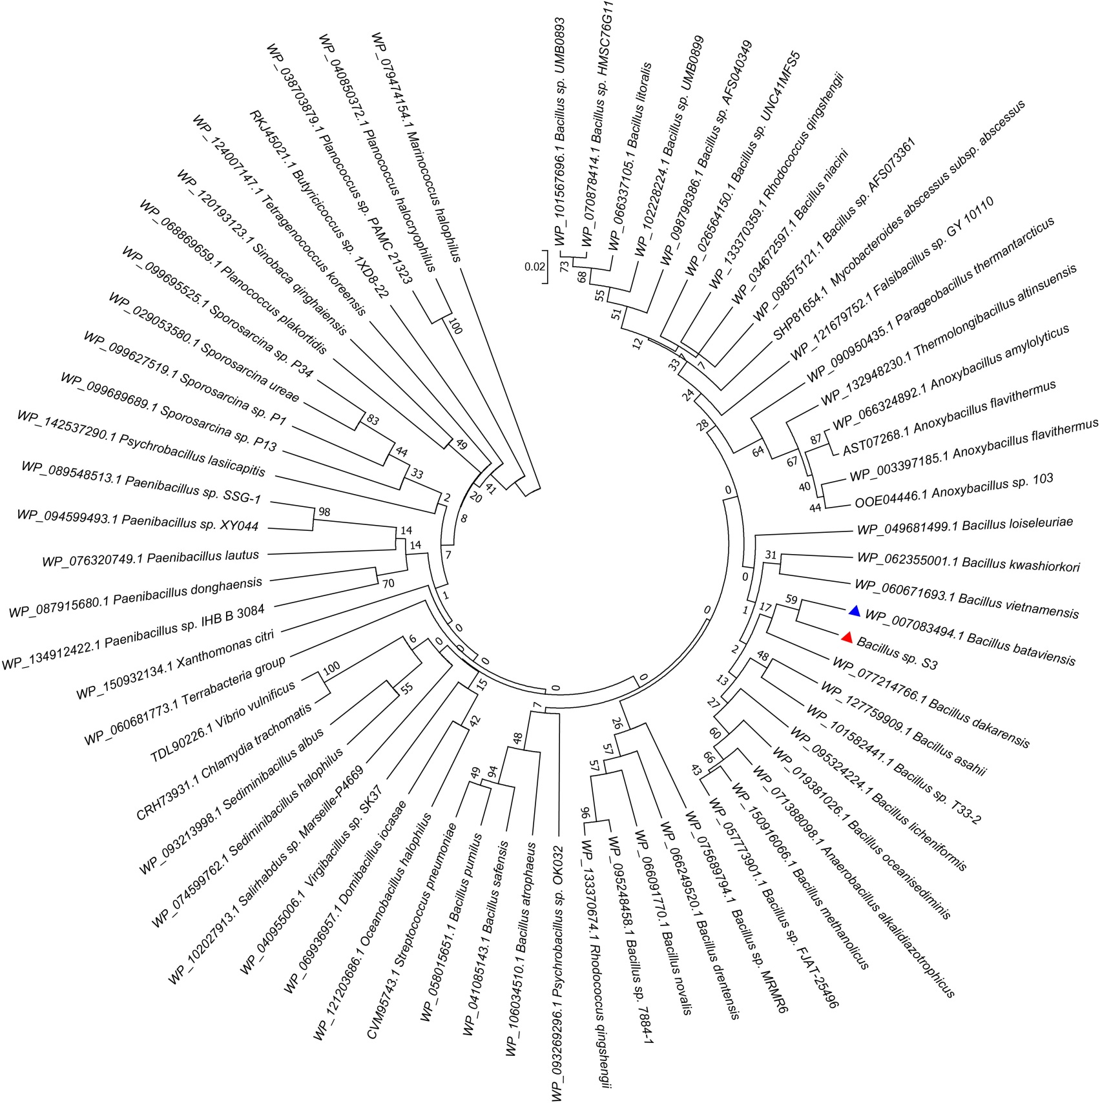
Supplementary Figure 16.

Supplementary Tables
Supplementary Table 1 The quality control of clean date.
Metrics | Raw Reads | Filtered Reads
Polymerase Read Bases | 1055530596 | 874728983
Polymerase Reads | 150292 | 88313
Polymerase Read N50 | 13074 | 13621
Polymerase Read Length | 7023 | 9904
Polymerase Read Quality | 0.61 | 0.846

Supplementary Table 2 The statistical information and of clean date
Job Metric | Value
Polished Contigs | 2
Adapter Dimers (0-10bp) | 0.01%
Short Inserts (11-100bp) | 0.00%
Number of Bases | 874,728,983
Number of Reads | 88,313
N50 Read Length | 13,621
Mean Read Length | 9,904
Mean Read Score | 0.85
Mapped Reads | 79,457
Mapped Read Length of Insert | 7,429
Average Reference Length | 2,858,339
Average Reference Bases Called | 100.00%
Average Reference Consensus Concordance | 99.99%
Average Reference Coverage | 110.81
Coverage level | 874.7/5.4

Supplementary Table 3 The statistical information of genome sequencing and assembling procedures
Class | Value
coverage level (x) | 874.7/5.4
Contig N50 (bp) | 163277
kmer length (bp) | 127
Coverage | 99.99%

Supplementary Table 4 COG functional categories of Bacillus sp. S3
Category | Type | Function Description | Count | Percent (%)
Metabolism | C | Energy production and conversion | 233 | 5.33
Metabolism | E | Amino acid transport and metabolism | 352 | 8.05
Metabolism | F | Nucleotide transport and metabolism | 93 | 2.13
Metabolism | G | Carbohydrate transport and metabolism | 269 | 6.15
Metabolism | H | Coenzyme transport and metabolism | 107 | 2.45
Metabolism | I | Lipid transport and metabolism | 93 | 2.13
Metabolism | P | Inorganic ion transport and metabolism | 193 | 4.42
Metabolism | Q | Secondary metabolites biosynthesis, transport and catabolism | 44 | 1.01
Cellular processes and signaling | D | Cell cycle control, Cell division, chromosome partitioning | 42 | 0.96
Cellular processes and signaling | M | Cell wall/membrane biogenesis | 179 | 4.10
Cellular processes and signaling | N | Cell motility | 19 | 0.43
Cellular processes and signaling | O | Posttranslational modification, protein turnover, chaperones | 114 | 2.61
Cellular processes and signaling | T | Signal transduction mechanisms | 141 | 3.23
Cellular processes and signaling | U | Intracellular trafficking and secretion | 33 | 0.75
Cellular processes and signaling | V | Defense mechanisms | 74 | 1.69
Cellular processes and signaling | W | Extracellular structures | 0 | 0.00
Cellular processes and signaling | Y | Nuclear structure | 0 | 0.00
Cellular processes and signaling | Z | Cytoskeleton | 0 | 0.00
Information storage and processing | J | Translation, ribosomal structure and biogenesis | 165 | 3.77
Information storage and processing | A | RNA processing and modification | 0 | 0.00
Information storage and processing | B | Chromatin structure and dynamics | 0 | 0.00
Information storage and processing | K | Transcription | 221 | 5.06
Information storage and processing | L | Replication, recombination and repair | 201 | 4.60
Poorly characterized | R | General function prediction only | 450 | 10.30
Poorly characterized | S | Function unknown | 393 | 8.99
 | - | Not in COGs | 955 | 21.85

Supplementary Table 7 Digital DNA-DNA hybridization (dDDH) between Bacillus sp. S3 and other Bacillus genomes.
 |  | Formula 1 |  |  | Formula 2 |  |  | Formula 3
Query genome | Reference genome | DDH(%) | Model C.I.(%) | Distance | DDH(%) | Model C.I.(%) | Distance | DDH(%) | Model C.I.(%) | Distance
S3 | B. bataviensis LMG 21833 | 30.2 | 26.8-33.8 | 0.5105 | 25.9 | 23.6-28.4 | 0.5105 | 28.1 | 25.2-31.2 | 0.5924
S3 | B. vireti LMG 21834 | 21.5 | 18.3-25.1 | 0.6733 | 23.3 | 21-25.7 | 0.1880 | 20.8 | 18-23.8 | 0.7347
S3 | B. vireti DSM 15602 | 21.7 | 18.5-25.3 | 0.6687 | 23.4 | 21.1-25.8 | 0.1872 | 21 | 18.2-24 | 0.7307
S3 | B. soli NBRC 102451 | 21.4 | 18.2-25 | 0.6754 | 22.7 | 20.4-25.1 | 0.1931 | 20.6 | 17.9-23.7 | 0.7381
S3 | B. soli DSM 15604 | 21.8 | 18.6-25.4 | 0.6660 | 23.2 | 20.9-25.7 | 0.1886 | 21 | 18.3-24.1 | 0.7290
S3 | B. novalis NBRC 102450 | 21.8 | 18.5-25.4 | 0.6671 | 22.8 | 20.5-25.2 | 0.1924 | 20.9 | 18.2-24 | 0.7311
S3 | B.s novalis FJAT 14227 | 22 | 18.8-25.6 | 0.6612 | 23.3 | 21-25.7 | 0.1880 | 21.2 | 18.4-24.3 | 0.7249
S3 | B. licheniformis ATCC 14580 | 12.9 | 10.2-16.1 | 0.9796 | 28.2 | 25.9-30.7 | 0.1524 | 13.3 | 10.9-16 | 0.9827
S3 | B. licheniformis YNP1-TSU | 12.7 | 10-16 | 0.9869 | 21.2 | 18.9-23.6 | 0.2072 | 13.1 | 10.8-15.9 | 0.9896
S3 | B. subtilis subsp str. W23 | 13 | 10.3-16.2 | 0.9746 | 26.1 | 23.7-28.6 | 0.1663 | 13.3 | 11-16.1 | 0.9788
S3 | B. subtilis subsp str. 168 | 12.9 | 10.2-16.2 | 0.9759 | 29.5 | 27.1-32 | 0.1449 | 13.3 | 11-16.1 | 0.9794
S3 | B. asahii strain OM18 | 13.1 | 10.4-16.4 | 0.9656 | 34 | 31.6 - 36.6 | 0.1223 | 13.5 | 11.2-16.3 | 0.9698
S3 | Bacillus sp. LF1 | 14.8 | 11.9-18.2 | 0.8882 | 21.4 | 19.2-23.8 | 0.2051 | 15 | 12.5-17.8 | 0.9112
S3 | Bacillus sp. OK048 | 15.7 | 12.7-19.1 | 0.8522 | 20.4 | 18.2-22.8 | 0.2154 | 15.7 | 13.2-18.6 | 0.8841

Supplementary Table 8 Primers used in Real-time RT-PCR
Genes | Sequence(Forward primer/Reverse primer) | Annealing temperature (℃) | Length (bp)
aioB | 5’- GGTTGATTTCGCTTTCCCTG-3’ | 53.4 | 155
aioB | 5’- CGTGATGACAAGGGCAAAGC-3’ | 55.4 | 155
arsB_1 | 5’- GCCACCATTCCTACTCA -3’ | 52.2 | 182
arsB_1 | 5’- CGCTACAAGTGATACGG -3’ | 52.2 | 182
arsB_2 | 5’- TTGCTATCCCAGTTTCAC -3’ | 48 | 189
arsB_2 | 5’- CAATCAGCCAGTCCGTTA -3’ | 51.8 | 189
arsB_3 | 5’- TGAAGCGATTCGGGATGA-3’ | 57.5 | 130
arsB_3 | 5’- GAAGACGGCAACGACACC-3’ | 56.4 | 130
arsC | 5’- TAGGTGATGAGTGGGAAGTG-3’ | 55.4 | 251
arsC | 5’- ACCTTCTGCTTTCGCTGGAT-3’ | 55.4 | 251
psts_1 | 5’- CGTTCTTGTAAACCGTCCTG -3’ | 55.4 | 150
psts_1 | 5’- TAACCAATCGCACCTTCTG -3’ | 53 | 150
16s | 5’-AGAGTTTGATCCTGGCTCAG-3’ | 53.4 | 191
16s | 5’-GGTTACCTTGTTACGACTT-3’ | 55.6 | 191

